
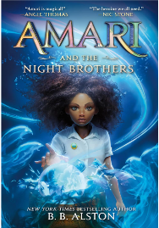 | Amari and the Night Brothers by B.B. Alston  Amari Peters has never stopped believing her missing brother, Quinton, is alive. So when she finds a ticking briefcase in his closet, containing a nomination for a summer tryout at the Bureau of Supernatural Affairs, she’s certain the secretive organization holds the key to locating Quinton—if only she can wrap her head around the idea of magicians, fairies, aliens, and other supernatural creatures all being real. Now she must compete for a spot against kids who’ve known about magic their whole lives. No matter how hard she tries, Amari can’t seem to escape their intense doubt and scrutiny—especially once her supernaturally enhanced talent is deemed “illegal.” But if she doesn’t stick it out and pass the tryouts, she may never find out what happened to Quinton.
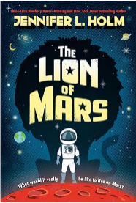 | The Lion of Mars by Jennifer L. Holm  Bell is just like any other kid. He loves cats, eats all kinds of cake, and is curious about everything. Oh, and he lives on another planet! Living on Mars comes with a ton of rules. Like don’t go outside without a buddy. Always keep a glow stick in your pocket. And no contact with the kids in the other settlements. Ever. Then a virus breaks out among the grown-ups, and the children are the only ones who can help. Suddenly it's up to Bell - a regular kid in a very different world - to uncover the truth and save his family ... and possibly unite an entire planet.
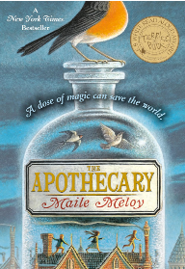 | The Apothecary by Maile Meloy  It's 1952 and the Scott family has just moved from Los Angeles to London. Here, fourteen-year-old Janie meets a mysterious apothecary and his son, Benjamin Burrows - a fascinating boy who's not afraid to stand up to authority and dreams of becoming a spy. When Benjamin's father is kidnapped, Janie and Benjamin must uncover the secrets of the apothecary's sacred book, the Pharmacopoeia, in order to find him, all while keeping it out of the hands of their enemies - Russian spies in possession of nuclear weapons. Discovering and testing potions they never believed could exist, Janie and Benjamin embark on a dangerous race to save the apothecary and prevent impending disaster.
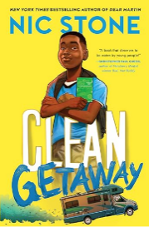 | Clean Getaway by Nic Stone  How to Go on an Unplanned Road Trip with Your Grandma:  - Grab a Suitcase: Prepacked from the big spring break trip that got CANCELLED.  - Fasten Your Seatbelt: G'ma's never conventional, so this trip won't be either.  - Use the Green Book: G'ma's most treasured possession. It holds history, memories, and most important, the way home.  What Not to Bring:  - A Cell Phone: Avoid contact with Dad at all costs. Even when G'ma starts acting stranger than usual.
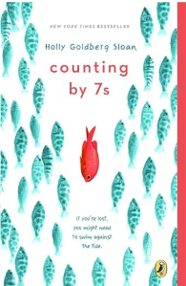 | Counting by 7’s by Holly Goldberg Sloan  Willow Chance is a 12-year-old genius, obsessed with nature and diagnosing medical conditions, who finds it comforting to count by sevens. It has never been easy for her to connect with anyone other than her adoptive parents, but that hasn’t kept her from leading a quietly happy life...until now. Suddenly Willow’s world is tragically changed when her parents both die in a car crash, leaving her alone in a baffling world. The triumph of this book is that it is not a tragedy. This extraordinarily odd, but extraordinarily endearing, girl manages to push through her grief. Her journey to find a fascinatingly diverse and fully believable surrogate family is a joy to read.
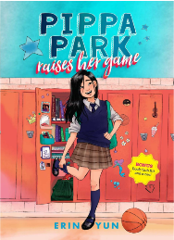 | Pippa Park by Erin Yun  Life is full of great expectations for Korean American Pippa Park. It seems like everyone, from her family to the other kids at school, has a plan for how her life should look. When Pippa gets a mysterious basketball scholarship to Lakeview Private, she jumps at the chance to reinvent herself. At school, Pippa juggles old and new friends, a crush, and the pressure to get As and score points while keeping her past and family’s laundromat a secret from her elite new classmates. But when Pippa begins to receive a string of hateful, anonymous messages via social media, her carefully built persona is threatened. As things spiral out of control, Pippa wonders if she can keep her old and new lives separate, or if she should even try.
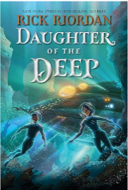 | Daughter of the Deep by Rick Riordan  Ana Dakkar is a freshman at Harding-Pencroft Academy, a five-year high school that graduates the best marine scientists, naval warriors, navigators, and underwater explorers in the world. Ana's year culminates with the class's weekend trial at sea, the details of which have been kept secret. She only hopes she has what it'll take to succeed. All her worries are blown out of the water when, on the bus ride to the ship, Ana and her schoolmates witness a terrible tragedy that will change the trajectory of their lives.
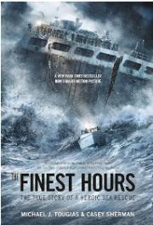 | Finest Hour by Michael J. Tougias & Casey Sherman  On the night of February 18, 1952, during one of the worst winter storms that New England has ever seen, two oil tankers just off the shore of Cape Cod were torn in half. With the storm in full force and waves up to 70 feet high, four coast guardsmen headed out to sea in a tiny lifeboat to come to the rescue. They were the only hope for the stranded sailors. Despite incredible obstacles, these brave men risked their lives, remembering the unofficial Coast Guard motto: You have to go out, but you do not have to come back.
 | A Thousand Questions by Saadia Faruqi  Mimi is not thrilled to be spending her summer in Karachi, Pakistan, with grandparents she’s never met. Secretly, she wishes to find her long-absent father, and plans to write to him in her beautiful new journal. The cook’s daughter, Sakina, still hasn’t told her parents that she’ll be accepted to school only if she can improve her English test score—but then, how could her family possibly afford to lose the money she earns working with her Abba in a rich family’s kitchen? Although the girls seem totally incompatible at first, as the summer goes on, Sakina and Mimi realize that they have plenty in common—and that they each need the other to get what they want most.
 | Percy Jackson and the Lightning Thief by Rick Riordan  Percy Jackson is about to be kicked out of boarding school . . . again. And that's the least of his troubles. Lately, mythological monsters and the gods of Mount Olympus seem to be walking straight out of the pages of Percy's Greek mythology textbook and into his life. And worse, he's angered a few of them. Zeus's master lightning bolt has been stolen, and Percy is the prime suspect. Now Percy and his friends have just ten days to find and return Zeus's stolen property and bring peace to a warring Mount Olympus. But to succeed on his quest, Percy will have to do more than catch the true thief: he must come to terms with the father who abandoned him; solve the riddle of the Oracle, which warns him of betrayal by a friend; and unravel a treachery more powerful than the gods themselves.
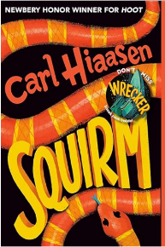 | Squirm by Carl Hiaasen  Some facts about Billy Dickens: He once saw a biker swerve across the road in order to run over a snake. Later, that motorcycle somehow ended up at the bottom of a canal. Billy isn't the type to let things go.  Some facts about Billy's family: They've lived in six different Florida towns because Billy's mom insists on getting a house near a bald eagle nest. Billy's dad left when he was four and is a total mystery. Billy has just found his dad's address--in Montana.  This summer, Billy will fly across the country, hike a mountain, float a river, dodge a grizzly bear, shoot down a spy drone, save a neighbor's cat, save an endangered panther, and then try to save his own father.
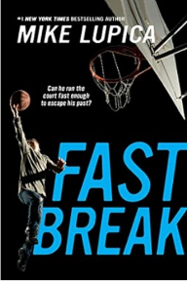 | Fast Break by Mike Lupica  Forced to live on his own after his mom dies and her boyfriend abandons him, 12-year-old Jayson does whatever it takes to get by. He manages to get away with his deception until the day he gets caught stealing a new pair of basketball sneakers. Game over. Within a day a social worker places him with a family from the other side of town, the Lawtons. New home, new school, new teammates. Jayson, at first, is combative, testing the Lawtons' patience at every turn. He wants out, yet the Lawtons refuse to take the bait. It's on Jayson to believe that he deserves a better life than the one he once had. The ultimate prize if he can? A trip to play in the state finals at Cameron Indoor Stadium–home to the Duke Blue Devils and launching pad to his dream of playing bigtime college ball.
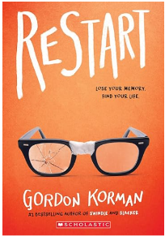 | Restart by Gordon Korman  Chase's memory just went out the window. Chase doesn't remember falling off the roof. He doesn't remember hitting his head. He doesn't, in fact, remember anything. He wakes up in a hospital room and suddenly has to learn his whole life all over again . . . starting with his own name. He knows he's Chase. But who is Chase? When he gets back to school, he sees that different kids have very different reactions to his return. Some kids treat him like a hero. Some kids are clearly afraid of him. One girl in particular is so angry with him that she pours her frozen yogurt on his head the first chance she gets. Pretty soon, it's not only a question of who Chase is--it's a question of who he was . . . and who he's going to be.
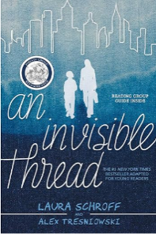 | An Invisible Thread by Laura Schroff  Stopping was never part of the plan... She was a successful ad sales rep in Manhattan. He was a homeless, eleven-year-old panhandler on the street. He asked for spare change; she kept walking. But then something stopped her in her tracks, and she went back. And she continued to go back, again and again. They met up nearly every week for years and built an unexpected, life-changing friendship that has today spanned almost three decades. Whatever made me notice him on that street corner so many years ago is clearly something that cannot be extinguished, no matter how relentless the forces aligned against it. Some may call it spirit. Some may call it heart. It drew me to him, as if we were bound by some invisible, unbreakable thread. And whatever it is, it binds us still.​

